Christina Buffo and Midori Yang

**User’s Manual**

There are two main components to the GUI for LifeSaver.java: the schedule display screen and the course input screen.

Here’s an example of the schedule display screen, showing six total entered classes (plus one lab), five visible classes and one hidden class:

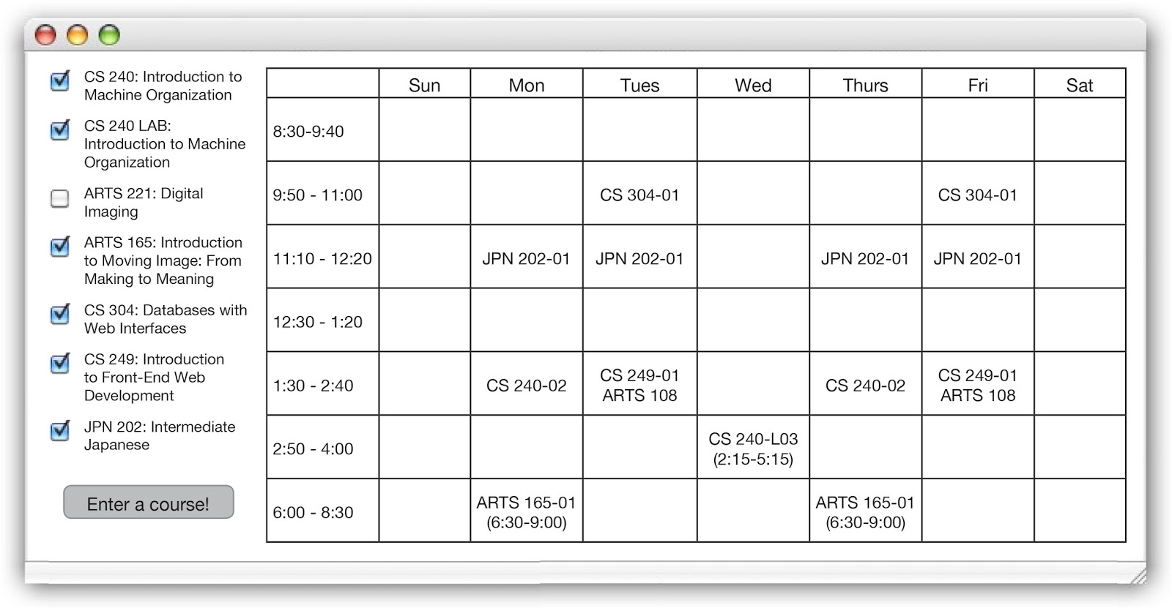

On the left of the schedule display screen is a list of all the courses that the user has already entered.  Next to each is a checkbox, and by checking or unchecking said checkbox, the user can determine which courses to display in the schedule.

At the bottom of the course list is a button “Enter a course!”, which prompts the course input screen (see below).

On the right of the schedule display screen is a chart corresponding to a week of courses, displaying the days of the week from Sunday to Saturday.  The farthest leftmost column lists the most common Wellesley course times, and classes that fall into that timeframe are listed in that row under the appropriate day.  Any classes that fall outside of this regular time block (such as CS240 LAB or ARTS 165 in the example above) are displayed in the closest preset time block with their start and end times listed below.

If the user enters another class that conflicts with one of the previously displayed classes, the new class is automatically hidden and the user is informed of the conflict.

For adding new classes from the “Enter a course!” button, the course input screen appears:

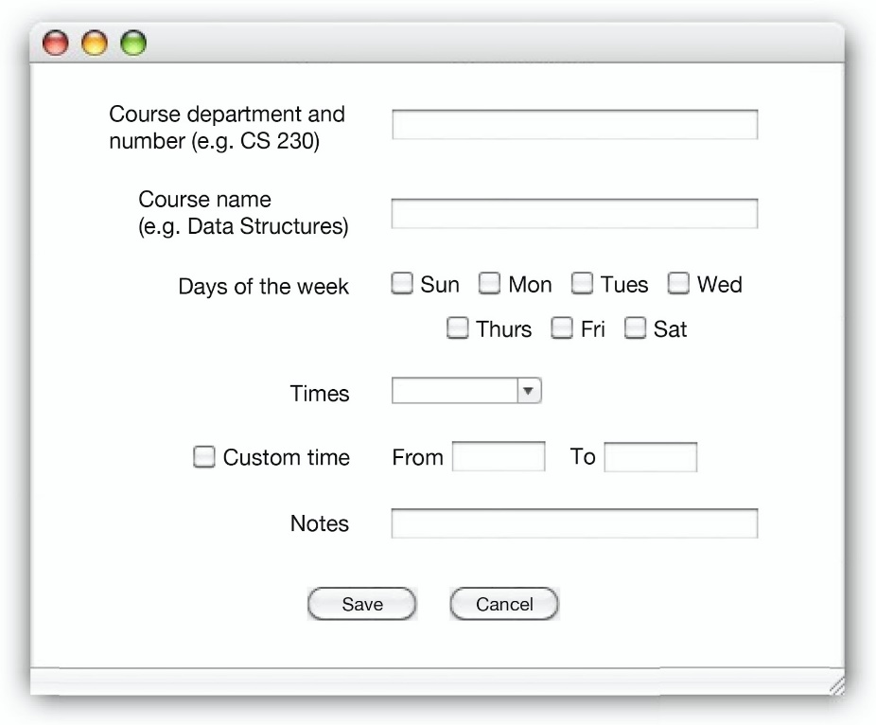

In the course input screen, the user will enter certain mandatory information, such as the course department and number, such as CS230, the days of the week, and the time.  Check boxes correspond to every day of the week, and the user specifies which days the class meets.  A dropdown box allows the user to pick from any of the most common class meeting times, or they have the option to instead specify a custom time.

Any additional information (such as professor or room number) can be entered in the notes section.

After all information has been input and the save button is clicked, the program will check to see if the most recently entered class conflicts with any previously entered class.  If it does, as mentioned above, the user will receive a notification and the new class will be hidden and added to the list of all entered classes.